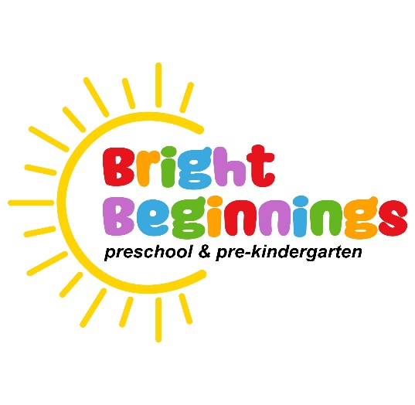
A Ministry of Tower Church
248 South Broad Street
Grove City, PA 16127
Tel: (724) 458-7260

“Teach children how they should live, and they
will remember it all their life.” Proverbs 22: 6

Application for Preschool & Pre-Kindergarten Enrollment
2024-2025 School Year
Child’s Name: _____________________________________________
Date of Birth: _____________________________________________
Gender: ______ Boy ______ Girl

Father’s Name: _____________________________________________
Address: _____________________________________________
_____________________________________________
Home Phone: ________________Work Phone: _________________

Mother’s Name:_____________________________________________
Address: _____________________________________________
_____________________________________________
Home Phone: ________________Work Phone: _________________

Child Lives With: ____Both Parents ____Mom ____Dad
Health / Medical Information
List known allergies: ________________________________________
________________________________________
Medications: ________________________________________
Does your child have special needs: __________________________
If so, explain: ________________________________________
__________________________________________________________
Other medical information: ___________________________________
__________________________________________________________

Please Select the Program Appropriate for Your Child

_____ PRESCHOOL 3-4 YEARS OLD
Tuesday / Thursday 8:30 AM – 11:00 AM
Cost: $ 125.00 / Month (9 months)
Child must be 3 years old by September 1, 2024

______ PRE-KINDERGARTEN 4-5 YEARS OLD
Monday / Wednesday / Friday 8:30 AM – 11:00 AM
Cost: $ 150.00 / Month (9 months)
Child must be 4 years old by September 1, 2024

Please note: The 2024-2025 Preschool and Pre-Kindergarten school year follows the Grove City Area School District Calendar.

Page 2
Admission

  - A non-refundable application fee of $30.00 must accompany your application.

Pay to : Tower Church (Memo: Bright Beginnings)
248 South Broad Street
Grove City, PA 16127

  - A copy of your child’s immunization record is required for admission.
  - All children must be toilet trained.
  - It is understood that your child’s acceptance into this program is subject to approval.

_____________________________________ ________________
Parent Signature Date

Statement of Confidentiality
The information contained herein is confidential and solely for the use of the Director and Teaching Staff of Bright Beginnings Preschool and Pre-Kindergarten. Information will not be made public or released to any individual or entity without written permission of the child’s parent(s) or legal guardian(s). Bright Beginnings Preschool and Pre-Kindergarten is a ministry of Tower Presbyterian Church, Grove City, Pennsylvania.

Office Use Only

Date Received:____________________ Date Reviewed:______________________

Fee Received: ____________________ Immunization Record:_________________

Parents Notified:__________________ Additional Information: _______________

Page 3

